May 2025 Breakfast @ USD 399

Sunday | Monday | Tuesday | Wednesday | Thursday | Friday | Saturday
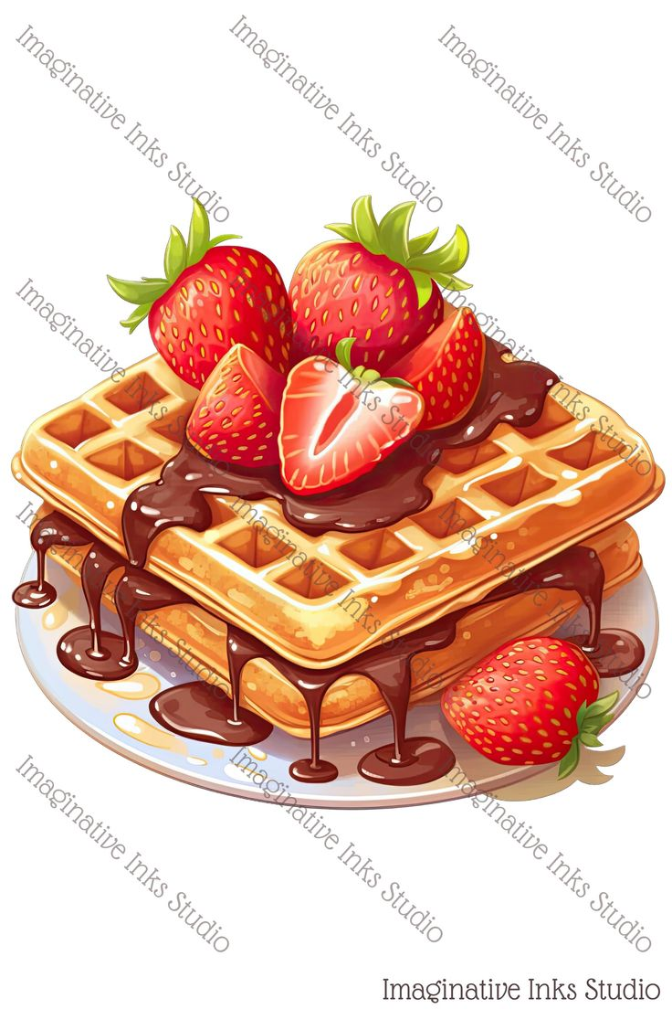 |  | This institution is an equal opportunity provider. | MENUS ARE SUBJECT TO CHANGE WITHOUT PRIOR NOTICE | 1  Oatmeal Breakfast Round  Yogurt  Peaches  Juice  Milk | 2 | 3
4 | 5  Cereal  Sausage Patty  Pears  Strawberries  Milk | 6  Scone  Mangos  Juice  Milk | 7  Pancake on a Stick  Mandarin Oranges  Banana  Milk | 8  Breakfast Pizza  Tropical Fruit  Juice  Milk | 9 | 10
11 | 12  Oatmeal Breakfast Round  Sausage Patty  Mixed Fruit  Juice Milk | 13  Mini Waffles w/Syrup  Applesauce  Clementine Orange  Milk | 14  Cinnamon Roll  Yogurt  Strawberries  Peaches  Milk | 15  Rice Krispy Treat  String Cheese  Pineapple  Juice Milk | 16 | 17
18 | 19 | 20 | 21 | 22 | 23 | 24
25 | 26 | 27 | 28 | 29 | 30 | 31  

